Title of the article in English (maximum 20 words)

Title of the article in Spanish (maximum 20 words)

Author's full names and surnames 1¹; Author's full names and surnames 2²; Author's full names and surnames 3³; Author's full names and surnames 4⁴

Abstract

This document is a template for the preparation of articles for the journal Boletín de Coyuntura, in addition, for the preparation of manuscripts, please follow the instructions for the preparation of articles of the journal available at the link. The abstract should be a single paragraph (minimum 150 and maximum 200 words) and should include the objective of the study, methodology and main conclusion.

Keywords: keyword 1, keyword 2, keyword 3, keyword 4, keyword 5. (minimum 3 and maximum 5 keywords)

Resumen

The resumen is the abstract translated into Spanish.

Palabras clave: palabra 1, palabra 2, palabra 3, palabra 4, palabra 5. (The palabras clave are the keywords translated into Spanish)

Introduction

The introduction section should include the purpose, importance, historical research background and current knowledge of the subject; that is, state the need to address the question or questions to be answered, define the problem and objectives.

Methodology

In the case of a scientific research article, the methodology should indicate the research methods used for the preparation of the manuscript, and in the case of primary information, the population and calculated sample should be stated and the selection of that population should be justified.

On the other hand, if the article is a review article, the methodology should state how, with what criteria and what works have been selected and reviewed.

In the reflection article, the methodology section is omitted.

Results/Development and Discussion/Reflection (as appropriate to the article)

The results section is placed in scientific research articles, where results that respond to the objectives and hypotheses of the study must be presented with qualitative or quantitative data.

The development and discussion section belongs to the review articles, where the most outstanding details of the articles reviewed and the discussed and argued synthesis of the results are presented.

The reflection section is placed in the reflection articles, where the author's ideas, arguments and reflections are presented in a coherent manner, as a result of a training, research and analysis process; they are based on a fundamental topic around which the author reflects and elaborates argumento.
For all the articles mentioned above, tables should have only horizontal lines and white background (similar to APA seventh edition format), and should be auto-adjusted to the window and single-spaced. On the other hand, figures should be in grayscale.

Place the sources of tables and figures according to the following cases:

- In case it is exactly taken from any institution, article, journal or other, place, for example:

Source: National Institute of Statistics and Census INEC, Yearbook of Vital Statistics - Births and Deaths (2014)

- If the author makes any modification, summary or other to the information, it should be stated, for example:

Source: own elaboration based on the National Institute of Statistics and Census INEC, Yearbook of Vital Statistics - Births and Deaths (2014)

- In the case that it is elaborated by the author with primary information, it should state:

Source: own elaboration based on (surveys, observation, interviews, etc.) (2014)

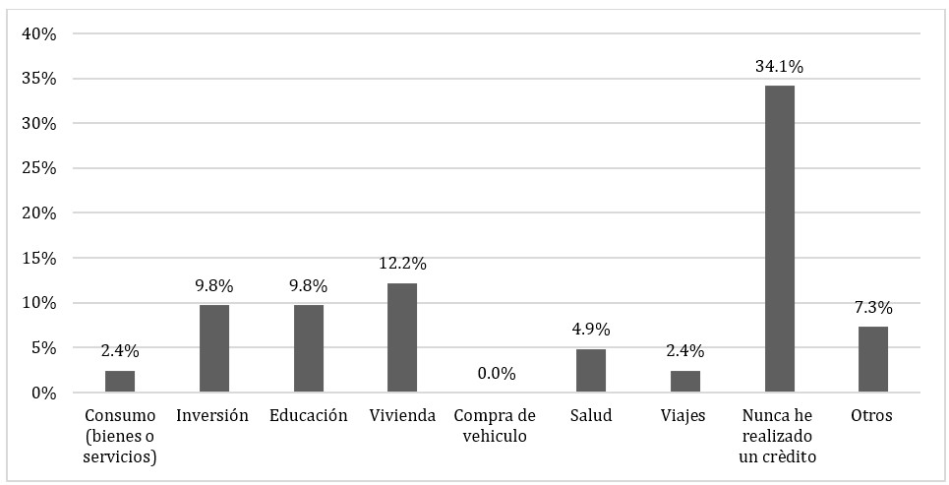
Source: own elaboration based on surveys (2023)
Figure 1. Use made of credits received

Source: own elaboration based on surveys (2023)
Figure 2. Time to a place where money transactions can be made (remittances, payments, collections)
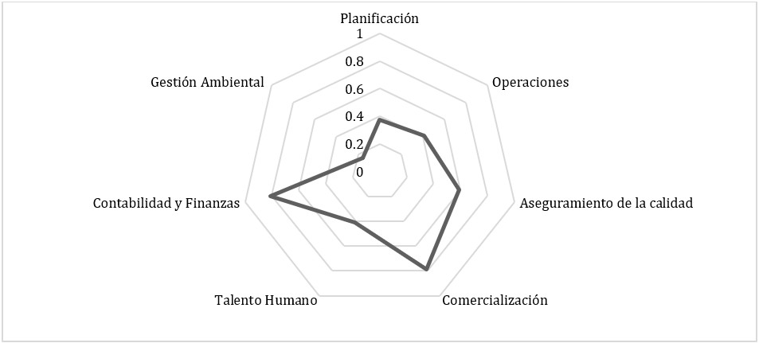
Source: own elaboration based on results obtained
Figure 3. Assessment of the factors of the bar competitiveness index

Table 1. Validation of the general hypothesis by Spearman's rho statistic
 |  |  | X job motivation | Y work performance
Spearman's Rho | X job motivation | Correlation coefficient | 1.000 | 0.619
 |  | Sig. (bilateral) |  | 0.000
 |  | N | 33 | 33
 | Y work performance | Correlation coefficient | 0.619 | 1.000
 |  | Sig. (bilateral) | 0.000
 |  | N | 33 | 33
Source: own elaboration based on surveys (2014)

In the figures of the articles in Spanish separate thousands with a period and decimals with a comma, while in the figures of the articles in English separate thousands with a comma and decimals with a period. This does not apply to years.

Conclusions

In the case of a scientific research article, the conclusions should highlight the most important contribution of the article in response to the research objectives.

For the review articles, the conclusions should present the consequences drawn from the review, proposals for new hypotheses and specific lines of research for the future.

For the reflection articles, the conclusions should mention the results of the reflections presented above, as well as a scenario for self-criticism, limitations or possible variables in future research.

For all types of articles, the length of the conclusions must be at least 500 words.

References

(All references should be written in alphabetical order, with French indentation and using APA seventh edition. In addition, all references listed should be properly cited in the body text of the manuscript using the same APA seventh edition standards available at the following link) (the minimum number of references are: scientific research article (15), review article (30) and reflection article (25)).

Barton, D. and Hamilton, M. (2004). Literacy understood as social practice. In V. Zavala, M. Niño-Murcia and P. Ames (Eds.). Writing and society. New theoretical and ethnographic perspectives (pp. 109-139). Network for the development of social sciences in Peru.

Castro, B. (2016). Construction and transformation of masculinities of sugarcane cutters in Valle del Cauca. Revista Colombiana de Sociología, 39(1), 79-102.

Hoyos-Hernández, P., Sanabria, J., Orcasita, L., Valenzuela, A., González, M., & Osorio, T. (2019). Social representations associated with HIV/AIDS in Colombian university students. Saúde e Sociedade, 28(2), 227-238. https://doi.org/10.1590/s0104-12902019180586

Jackson, L. M. (2019). La psicología del prejuicio: De las actitudes a la acción social (2ª ed.). American Psychological Association. https://doi.org/10.1037/0000168-000

Ministry of Health and Social Protection (2016). Comprehensive Health Care Policy. https://www.minsalud.gov.co/sites/rid/Lists/BibliotecaDigital/RIDE/DE/modelo-pais- 2016.pdf.

Morales, M. A. (2018). How to embrace, from a person-centered approach, difficult tutoring? The Scribe, 5. https://issuu.com/centrodescritura/docs/revistaelescribanon5

World Health Organization [WHO]. (2017, April 1). Malnutrition. https://www.who.int/es/news-room/fact-sheets/detail/malnutrition

